**Practical-2**

**Aim: Perform the user’s view analysis: Use case diagram.**

**2.1 Use Case Diagram:**

**2.1.1 Introduction:**

The purpose of the Propre Cuisine is to revolutionize the cooking experience by providing a user-friendly platform that offers an innovative way to utilize leftover ingredients. This application is designed to enhance culinary creativity, reduce food waste, and provide users with personalized recipe recommendations. By leveraging digital technologies, "Propre Cuisine" contributes to sustainable cooking practices while catering to the needs of both users and the culinary community.

Propre Cuisine is a sophisticated food recipe application designed to transform the way people cook by utilizing leftover ingredients effectively.

Use case diagrams are a common way to communicate the major functions of a software system. A use case diagram at its simplest is a representation of a user's interaction with the system that shows the relationship between the user and the different use cases in which the user is involved. A use case diagram can identify the different types of users of a system and the different use cases and will often be accompanied by other types of diagrams as well.

Use cases are nothing but the system functionalities written in an organized manner. Now another thing which is relevant to the use cases are the actors. Actors can be defined as something that interacts with the system.

So in brief, the purposes of use case diagrams can be as follows:

* Used to gather requirements of a system.
* Used to get an outside view of a system.
* Identify external and internal factors influencing the system.
* Show the interacting among the requirements are actors.

**2.1.2 Symbols used in Use Case diagram:**

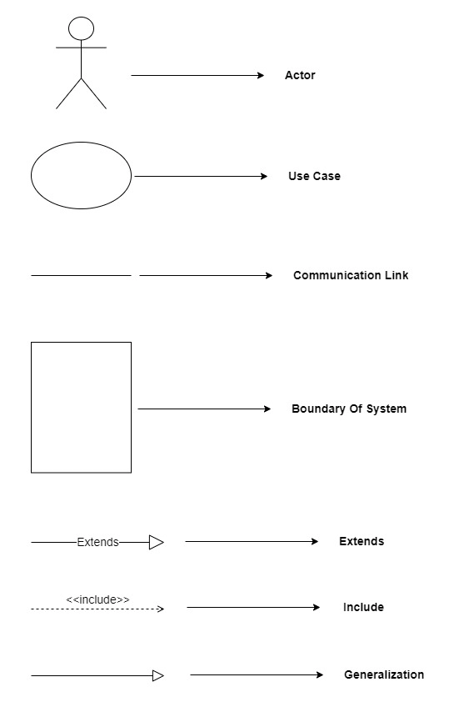

**2.1.3 Use Case diagram for PreMarriage System :**

